LAB 14
(Total Marks 10)
Instructions:
- Lab is viva based only in lab hours.
- Use hooking interrupt.
- Use enable and disable interrupts on required positions.
- Use “in” instruction to read character from keyboard.
- Use PIC 60

Task 1: Write a program that detects if a character entered by the user is his/her full name or not using hardware interrupt. And Display Y in case of yes else N.
[org 0x0100]
jmp start

kbisr:
push ax
push es
mov ax, 0xb800
mov es, ax
in al, 0x60

cmp al, 0x13 ; Check if the key is 'R'
je displayTrue

cmp al, 0x1E ; Check if the key is 'A'
je displayTrue

cmp al, 0x21 ; Check if the key is 'F'
je displayTrue

cmp al, 0x15 ; Check if the key is 'Y'
je displayTrue
jmp displayFalse ; If none of the keys matched, display 'F' for false

displayTrue:
mov byte [es:0], 'Y' ; Display 'Y' for true
jmp nomatch

displayFalse:
mov byte [es:0], 'N' ; Display 'N' for false

nomatch:
mov al, 0x20 ; send EOI to PIC
out 0x20, al
pop es
pop ax
iret

start:
mov ax, 0
mov es, ax ; point es to IVT base
cli ; disable interrupts
mov word [es:9*4], kbisr
mov [es:9*4+2], cs
sti

l1:
jmp l1

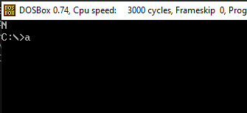

Task 2: Write a program that displays an indicator on the screen when the CAPS Lock key is pressed using hardware interrupt. The indicator should toggle between 'ON' and 'OFF' with each press.
[org 0x0100]
jmp start

kbisr: push ax
push es
mov ax, 0xb800
mov es, ax
in al, 0x60
cmp al, 0x3a ; is the key left shift
jne nextcmp ; no, try next comparison
mov byte [es:0], 'T' ; yes, print true at top left
jmp nomatch ; leave interrupt routine
nextcmp:
mov byte [es:0], 'F' ; yes, print false at top left
nomatch: mov al, 0x20
out 0x20, al ; send EOI to PIC
pop es
pop ax
iret

start:
mov ax, 0
mov es, ax ; point es to IVT base
cli ; disable interrupts
mov word [es:9*4], kbisr
mov [es:9*4+2], cs
sti
l1: jmp l1
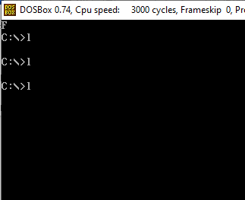
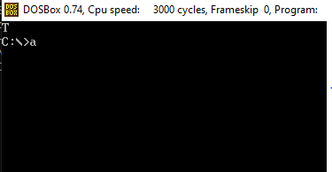

Best of luck

